Multi-functions CCTV Tester TECHNOLOGY

X7 series︱4K HD camera test

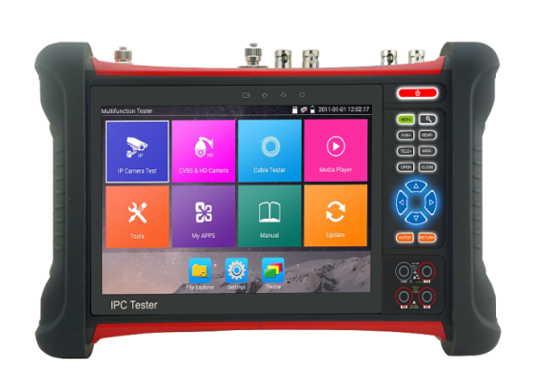
All-in-one CCTV tester
◆7 inch retina touch screen, 1920*1200 resolution
◆ 8MP TVI, 8MP CVI, 8MP AHD & SDI/ 8MP EX-SDI test *
◆ H.265/H.264, 4K video display via mainstream
◆ Dahua, Hikvision, Axis etc ONVIF camera test
◆ ◆Chrome browser, set Axis etc cameras parameters
◆ Built in WIFI, create WIFI hotspot
◆ 4K HDMI output, 1080P HDMI Input
◆ DC12V 2A, DC48V PoE power output
◆ Rapid ONVIF, auto view video and create testing report
◆ UTP cable tester /RJ45 cable TDR test, cable quality test
◆ Cable tracer and video leverl meter
◆ Tester Play: Tester, mobile phone, PC display at the same time
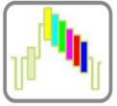
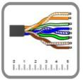
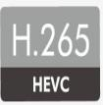
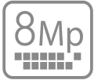
Application

The 7 inch touch screen IP camera tester is designed for maintenance and installation of IP analog, HD coaxial cameras as well as other security equipment. The 1920x1200 resolution enables it to display network HD cameras and analog cameras in high resolution. The unit supports many ONVIF PTZ and analog PTZ control. Additional, it with other functions TDR cable test, Digital multi-meter, UTP cable test and cable scan etc. CCTV installers often need to carry a variety of testing tools to complete their work. If take the all in one camera tester, making working conditions safer and increasing productivity.
CCTV system installation and maintenance
Network cabling project installation and maintenance
Dome camera, IP TVI CVI AHD SDI 4K H.265 camera testing
Video transmission channel testing
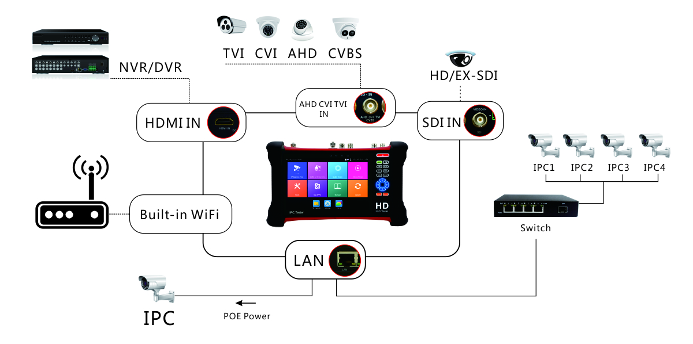
PTZ controller

Features

Camera test:
● 7 inch retina touch screen, 1920*1200 resolutions
● H.265 & H .264 IP, 4K video display via mainstream
● 8MP TVI test,3840 x 2160P 12.5/15 fps,4xzoom ,video record &playback ,coaxial PTZ control & call OSD menu *
● 8MP AHD test, 3840x2160P 15 FPS, 4xzoom, video record & playback, coaxial PTZ & call OSD menu *
● 8MP CVI test, 3840 x 2160P 12.5/15fps, 4xzoom, video record& playback, coaxial PTZ & call OSD menu *
● 8MP EX-SDI test, 3840 x 2160P 25/30 FPS,4xzoom, video record& playback, coaxial PTZ & call OSD menu *
● HD-SDI test, 1920 x 1080P 25/30/50/60 FPS, 4xzoom, video record& playback, coaxial PTZ & call OSD menu *
● 3G-SDI test, 1920 x 1080P 50/60 FPS, 4xzoom, video record& playback, coaxial PTZ & call OSD menu *
● 4K HDMI Output, support 30fps
● Rapid ONVIF, Auto log in and display image, create testing report
● AXIS, Hikvision camera test, enter ONVIF app, input username and password to test
● CVBS camera test and PTZ control
● IPC TEST (Non-ONVIF test), HIK test tool (Hikvision camera),DH test tool (Dahua camera)
● Video level meter, peak video signal level, SYNC signal level, Color bar chroma level measurement
●DC12V/2A power output, camera can be powered from DC 12Votage
● 48V PoE power output power
●Rapid video, just by one key to detect all network cameras and auto display
●Built in Wi-Fi, display image from the wireless camera, create WIFI hotspot
● CVBS loop test, the tester send and receive color bar generator signal, to check BNC cable
● Enhanced Color bar generator, PAL/NTSC multi-system color bar video generator
Cable test:
● Improvement cable tester, UTP cable, telephone cable etc order and connectivity test, can save testing report, if special number, need customized
● RJ45 cable TDR test, test cable pair status, length, attenuation, reflectivity, impedance, skew etc
● Cable tracer, search BNC cable, network cable and telephone cable from the mess cables
● TDR cable test: BNC cable, network cable, telephone cable, RVV cable and elevator cable, cat 5/6 cable’s length and short circuit. measurement range 1.2KM*
Other functions:
● Network tool: Ping, IP scan, Port Flash, DHCP server, Trace Route
● POE & power information, DC12V& PoE power and voltage output /input measurement
● Tester Play: Tester, android version mobile phone and PC display at the same time
● Shortcut button, drop-down menu, can select Poe power, IP setting, CVBS, LAN info, HDMI IN etc
● HDM input, 720×480p /720×576p /1280×720p /1920×1080p /1024×768p/1280×1024p /1280×900p /1440×900p display,record and snapshot
● Traffic monitoring, display network port or WIFI connection real-time upload and download speeds and other network parameters
● Self -update software, you can install apps with android version
● Media player, 4K video files and MKV/MP4 media files play
● Quick office, quick office app (support excel, word, ppt format) doc. editable
● 8GB SD card including
●Display its genuine resolution of the IP camera images
● Audio in, support record and save the audio/LED lamp, calculators, music players and other application tools
● 7.4 V 5000mAh Lithium Ion Polymer Battery, after 6~7 hours charging , working time lasts 10 hours

Specifications

LCD | Item series | X7 series
 | Display | New 7 inch IPS touch screen , 1920*1200 resolution
Video Mode | CVBS | 1 channel BNC input & 1 channel BNC looped output, NTSC/PAL (Auto adapt)
 |  | Analog video level meter, peak video signal level, SYNC signal level, Color bar chroma level measurement
 |  | PTZ control,RS485 control, Baud 600-115200bps,compatible with more than 30 protocols such as PELCO-D/P, Samsung, Panasonic etc
 |  | CVBS loop test | the tester send and receive color bar generator signal , check BNC cable
 | IP camera test  4k/H.265/H.264 | IP Discovery/Quick ONVIF/IPC test /RTSP play /Client APK
 |  | Rapid Video | Auto view the video, create testing report
 |  | Hik test tool | activate hikvision camera , modify the user name, password and IP parameters
 |  | Dahua test tool | Dahua camera test, modify the user name, password and IP parameters
 | IP& CVBS test | IP& CVBS test at the same time ,converter test from analog to digital with dual test window
 | Coaxial HD test * | 8MP TVI camera test, 3840 x 2160P 12.5/15 FPS, UTC control/ call OSD menu *
 |  | 8MP CVI camera test, 3840 x 2160P 12.5/15 FPS,UTC control/ call OSD menu *
 |  | 8MP AHD test, 3840x2160P 15 FPS, UTC control/ call OSD menu *
 |  | 8MP EX-SDI, HD-SDI, 3G-SDI, UTC control & call OSD menu *
 | HDMI input | 1 channel HDMI input, support 1080P
 | Zoom Image | 4x zoom, to enlarge image, Screen snapshot, record ,save ,view and record and play back
Analog Video out | color bar generator | Output one channel PAL/NTSC color bar video signal for testing monitor or video cable
Power output | PoE power output | 48V PoE power output, max power 25.5W
 | DC12V power | DC12V /2A power output
Cable test | TDR cable test * | BNC cable, network cable, telephone cable, RVV cable and elevator cable, cat 5/6 cable’s length and short circuit. measurement range 1.2KM *
 | Cable tracer | search BNC cable, network cable and telephone cable from the mess cables
 | UTP cable test | Test UTP cable connection status and display on the screen. Read the number on the screen
 | RJ45 cable TDR test | Test cable pair status, length, attenuation, reflectivity, impedance, skew etc. measurement range 180M.
TesterPlay | screen projection：tester, mobile phone and PC display at the same time (For android version mobile phone)
Network test | Trace route, Link monitor , DHCP server, port flashing , Ping test
Wi-Fi | Built in WIFI,speeds150M,display wireless camera image
Audio test | 1 channel audio signal input, test whether sound normal, 1 channel audio signal, to connect headphone
Data monitor | Captures and analyzes the command data from controlling device, also can send hexadecimal
PoE test | Measurement POE switch or PSE power supply voltage and cable connection status
Drop-down menu | You can select PoE power switch ,IP setting,CVBS, LAN info , HDMI IN functions etc in any interface
External power supply | DC 12V 2A
Battery | Built-in 7.4V Lithium polymer battery , 5000mAh
Rechargeable | After charging 5~6 hours, normal working time 10hours
Operation setting | OSD menu, select your desired language: English, Chinese, Korean, Russian, Italian, French, Polish, Spanish, Japanese etc
Auto off | 1-30 (mins)
Working Temperature | -10℃---+50℃
Working Humidity | 30%-90%
Dimension/Weight | 255mm x 160mm x 46mm / 0.95Kg
Below are customizable functions, if need customize them, QTY MOQ is 50pcs,Full function model is X7-MOVTADHS
M | Digital Multimeter: DC and AC voltage measurement, Resistance measurement, Continuity test, Diode measurements, Capacitance measurement
O | Optical power meter, Wavelength：1625,1550nm,1490nm,1310nm,1300nm,850nm, measurement range ,-70 ～ +10 dBm, for optical power testing and Fiber link loss relative measurement
V | Visual fault locator : 10mW visual fault locator with 650nm wavelength can emit red laser sources to test multi-mode and single mode fiber’s bending and breakage, test range 10KM
T | TDR cable test: BNC cable, network cable, telephone cable, RVV cable and elevator cable, cat 5/6 cable’s length and short circuit. measurement range 1.2KM
A | 8MP AHD test, 3840x2160P 15 FPS, UTC control/ call OSD menu
H | 8MP TVI camera test, 3840 x 2160P 15 FPS, UTC control/ call OSD menu
D | 8MP CVI camera test, 3840 x 2160P 12.5/15 FPS,UTC control/ call OSD menu
S | 8MP EX-SDI, HD-SDI, 3G-SDI, UTC control/ call OSD menu
L | Video level meter: PEAK, SYNC signal level, color burst chroma level measurement (included)
C | Cable tracer: Search BNC cable, network cable and telephone cable from the mess cable (included)
Note: “*” sign mean functions are customizable
The data above is only for reference and any change of them will not be informed in advance. For more detailed technical inquiries, please feel free to contact us.

Packing kits

- Tester
2) Cable tracer
3). Adaptor DC12V 2A/ 8GB SD card
4) Polymer lithium ion battery (7.4V DC 5000mAh)
5). Tool bag / DC Power cable/BNC cable/ RS485 cable/ Audio cable/ Safety cord
6). SC, ST Connector（Only for optical power meter models）
7). Multi-meter test leads one pair of red and black (only for the Multi-meter models)
8). TDR alligator clamp (only for TDR models)
9). Manual

